

**BGA Guide to Virtual Learning 2.0**

**REVISED May 3, 2020**

**Introduction**

Boston Green Academy has laid a strong foundation for virtual learning under extremely challenging circumstances thanks to the amazing efforts of our staff. Now, with the unfortunate closing of school buildings for the rest of the year (the last day of school is now Friday, June 26th, or Day 185 as per DESE guidance), we need to enter a new phase of this work in order to make needed adjustments, decrease learning loss, and continue to support our students and their families. Based on agreements between the BPS and BTU, guidance from BPS and DESE, and extensive discussions within BGA (including the ILT), this document clarifies expectations for this new phase of virtual learning for the rest of this school year. This is how we will all proceed going forward. We deeply appreciate everyone’s efforts to make this work.

**Resource Documents**

[BPS Remote Learning Guide- Phase Two](https://drive.google.com/file/d/1RyLL2ugh7AbtSE-RrXflDG54Ft1nJSPc/view?usp=sharing)

[BPS/BTU MOU on Virtual Learning](https://drive.google.com/file/d/1ULTGES3UDf_jvQUrZ-tcHCTbGhzr6K-L/view?usp=sharing) (full text)

[BPS Summary of Agreement](https://drive.google.com/file/d/1yEtMQIyLtSVN1NANRgJ15H9PLm3jsNIV/view?usp=sharing)

[BTU Summary of Agreement](https://drive.google.com/file/d/1I2c9EtJ00Gm2u2gUTZAIjJAzZ1_tg2ht/view?usp=sharing)

**Summary of Expectations**

Teachers at BGA will do the following each week:

* **Conduct one synchronous (real-time) virtual lesson for each of their classes** using the block and master schedule below
* **Offer at least one synchronous (real-time) office hour** for their students based on the content area schedule below
* **Check-in directly with each of their Advisees on Wednesdays** and log all contact (see below)
* **Attend virtual grade level and staff meetings** each week as scheduled
* **Revise curriculum going forward to focus on grade level ‘power standards’ that have yet to be taught** as well as a review of key areas that are required to prepare students for next year’s classes
* **Develop and upload a weekly learning experience plan every Sunday night** as per guidance below
* **Document all work into the weekly work log (see below)**
* **Communicate with students and families and log all communication as required**, including the **taking of attendance once per week** in Aspen (see below)
* **Compute and enter grades** for Term 3 and Final Marks (policy TBA- see below)
* **Attend virtual professional development** as required (see below)
* **Use BPS Zoom accounts for all online connections** (see below)

SST members and Paraprofessionals at BGA also have new expectations in addition to what we’ve been doing previously. See section below for details.

**BGA Virtual Learning 2.0**

**Why do things have to change?**

**Think of May 4th as a reset.** We have learned a lot from what we’ve done already and want to make adjustments based on our experience. We know some students are doing well and others are not. We want to keep evolving so more students can access the work and make progress. We also need to meet the guidelines outlined in the MOU released by BPS/BTU and new expectations from DESE. Part of those expectations includes *“students will have an opportunity to connect with an available educator from their school for at least 3 hours of each day”* additionally *“teachers may be required to engage in 15 hours of synchronous time directed by the principal, with input from teachers, and an additional 5 hours of asynchronous time directed by the individual teacher, with input from the principal”.*

DESE is also now stating that new content can and should be taught (see details below) in addition to the review of prior topics. All of us must and can make adjustments so that the good work you have been doing is strengthened to meet these new expectations going forward.

To incorporate these expectations, provide stability and consistency for teachers and students; the BGA admin team, along with support and feedback from the ILT and LT, have created a bell schedule, a way of tracking the work we are doing, and a standard Zoom lesson plan format, among other things. Details on all of these are below.

**In terms of my role as a teacher, what exactly needs to change?**

**Keep track of your work hours and submit a log weekly.** There is high trust at BGA and always will be. The new BPS/BTU agreement requires schools to account for how all staff members are spending their time remotely as we are all being paid full time for the shutdown.

[The weekly log for staff hours can be found here.](https://drive.google.com/open?id=1zQ4DWYt3011H3rUeLqEEncHy-T0O37dn) Please go into the folder, make a copy of the log and rename it, so it says **YOUR LAST NAME Work Log (during closure 2020)**. Teachers will update their work logs to reflect what was done the week before, by Monday morning of each week throughout the closure. There is a tab for each week already on the spreadsheet. While compliance will be checked, thanks for completing this requirement on time every week so we can focus on learning for students, which is most important.

**Use a common weekly lesson plan template and share it with students.** [This is the template.](https://docs.google.com/document/d/1aSdVHBzt2uyWSY17aL1uALvvX7whHdLsQV1ZnxS_rmI/edit?usp=sharing) **Think of it as one cohesive learning experience throughout the course of a week.** It is broken into pre-work, classwork, and post-work. Simply put, you will ask students to come to class with some prior knowledge or practice. You will then create an agenda for a live lesson (see the suggested agenda flow within the template), and then students will have work to do after the experience that will be due at your discretion. All teachers must use this template at BGA going forward.

**When crafting each portion of your weekly learning experience, please use the following recommended time frames:**

**Prework =** Approximately 30-40 Minutes

**Classwork =** 50-60 minute Zoom classes

**Postwork =** Approximately 40-60 Minutes

**Screenshot of BGA’s Learning Experience Template:**

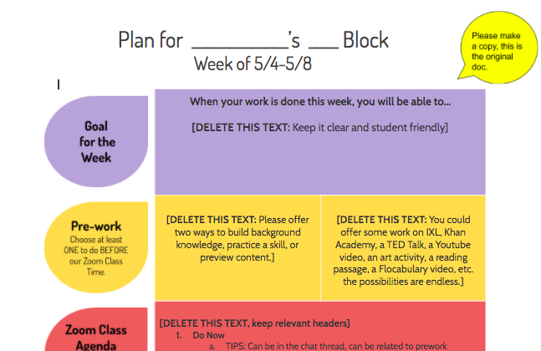

**Below are examples of the new template:**

[HS Science Example](https://docs.google.com/document/d/191ZzcjbMPR8vLMvulqvxCrBYR4VhY1Nk9pXEE47GjGE/edit?usp=sharing)

[HS Math Example](https://docs.google.com/document/d/1YjPlL_kxLUQlrF2EZF1BqcO7sFGqiIGmNZuRjKB3AJ8/edit?usp=sharing)

[HS ELA Example](https://docs.google.com/document/d/19owfX0VYS0yqOV16dQaTTpZmUYNy8FQByE8Pqjp4ZFI/edit?usp=sharing)

[MS ESL Example](https://docs.google.com/document/d/1upMjpcYZjP9EMC6Uspenml_8wWrdlNfk6JcT2TP3mBw/edit?usp=sharing)

[MS Science Example](https://docs.google.com/document/d/11K22Z0W7lhqwPKoxaGX4i4J1ZU-8KJa_yh_8QZgRiyc/edit?usp=sharing)

**Each grade level will use a common Weekly Overview as part of their Home Pate document.** All teachers are expected to use this [new weekly overview.](https://docs.google.com/spreadsheets/d/1eI2nL-kWtXklobjyi1yyRhMnMXHGRtOtjYCStRH5W1E/edit?usp=sharing) Starting the week of May 4th, each team is expected to replace and populate the calendar page of Home Plate with the new weekly overview by Sunday at 8 pm of each week.

Grade levels must calibrate the workload and due dates across classes to ensure an equitable experience for all students. No one class should dominate, and no one class should be offering less than others. Remember: students are expected to do 3 hours of work per day, or approximately 15 hours per week. This includes class time and other direct contact. Grade Level Teams will review this document together to ensure equity between classes. Amanda, Jeff and Matt will assist with any issues that arise.

**Screenshot of new weekly overview:**

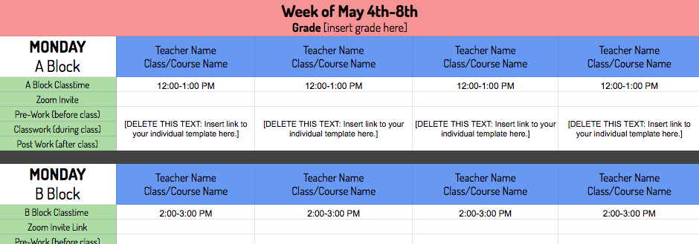

**How do I know what to teach? What is most important?**

DESE has released a guide to what standards in each subject area to teach for the rest of the year. [This guide is here](https://drive.google.com/file/d/1_LZbI2nOJz-A7cfOtzO6YDFn0Hq47T9u/view?usp=sharing). **All teachers should read this guide.** DESE is clearly saying that we should both teach select new content (aka ‘power standards’ that are foundational to being prepared for the next grade level and that are most likely to be assessed on MCAS) and review of major topics from earlier in the year that students must master to move forward. All teachers will have to make adjustments to their curriculum for May and June to incorporate this new guidance, especially in classes that have MCAS exams next year (Math, Science and ELA).

More user-friendly documents are also available that outline what is expected to be taught and learned in each grade level. The documents below are meant for families. However, they were created by DESE and highlight the primary things students should be able to do by the end of each grade level. This document may help teachers decide what to focus from May 4th through the end of the school year.

[MA Standards Resource for Families - Grade 6](http://www.doe.mass.edu/frameworks/pguide/g6.pdf)

[MA Standards Resource for Families - Grade 7](http://www.doe.mass.edu/frameworks/pguide/g7.pdf)

[MA Standards Resource for Families - Grade 8](http://www.doe.mass.edu/frameworks/pguide/g8.pdf)

[MA Standards Resource for Families - Grade 9-12](http://www.doe.mass.edu/frameworks/pguide/gHS.pdf)

**What else do I need to consider?**

This transition will be messy and then it will be over in the blink of an eye. Much like starting the school year, your first Zoom lesson will have to include an overview of expectations and Zoom etiquette and you will have to revisit the expectations over time. Ryne has resources available to you to aid in this. See them further below.

**That’s a lot to do. How can I keep it all straight?**

[Here is a checklist of “to-do” items](https://docs.google.com/spreadsheets/d/1Fl4g1vAhqGyAHjYrHd3cjieeEjEMBOaTaBvW9YZaqh4/edit?usp=sharing) for grade levels and individual teachers to keep track of tasks that need to be completed as we make this transition.

**Below is a screenshot from a webinar presented by MIT’s Teaching Systems Lab.** It is useful in framing what virtual learning experiences should look like during this pandemic.

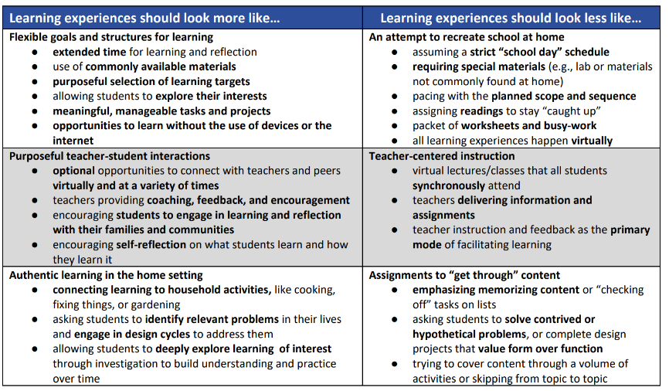

**What about our old BGA Online Learning Expectations?**

They served us well and still have lots to offer in terms of guidance and resources. While this new guidance supersedes the older document, please refer to the older document for lots of helpful resources and details not covered in this updated version. You can find the previous document at [BGA Online Learning Expectations (Revised April 5, 2020)](https://docs.google.com/document/d/1gIjlcS7d9vAt6y48Ya9qnhtj2k8ivyVTMlVWH7xxTeI/edit?usp=sharing).

**Grading Policy**

UPDATED MAY 3, 2020

After much delay, BPS released its grading policy on Friday, May 1st. This policy clarifies how to grade students before the Shutdown, during the Shutdown, and how to compute final grades for the year. It was done in collaboration with school leaders and addresses most, but not all, of the questions staff are likely to have. We will devote time at the Staff Meeting to discuss this and the ILT/LT wll review. While there are some details that BGA will have to decide, the overall policy is one we will follow during this Shutdown experience. We will also follow up with FAQs as quickly as possible. [The BPS grading policy can be found here](https://docs.google.com/document/d/1Chke8H4xSejZ_ulNo8DiRl-MC_SFYzp3jRJb5VKInO8/edit?usp=sharing).

UPDATED- here is the link to BGA’s Grading Policy for Remote Learning

**Attendance**

UPDATED MAY 3, 2020

The new BPS/BTU agreement requires all teachers to take weekly attendance in each class in Aspen. The term ‘attendance’ in this context means logging the engagement level of each student in each class every week (i.e. it can change from week to week as student engagement evolves). **Attendance must be input by every teacher in every class that is meeting (see master schedule below) in Aspen by 11am every Friday. The first day to enter attendance will be Friday, May 8th.** See details from BPS below:

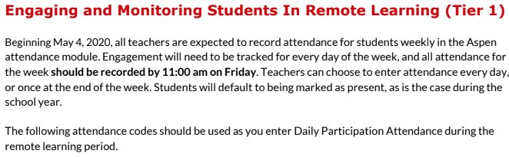

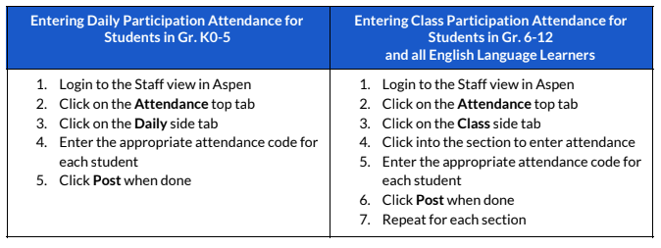

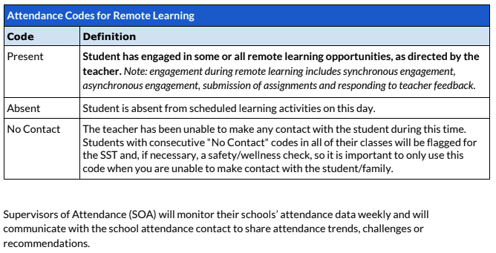

**Logging of Student/Family Contacts**

We continue to prioritize all efforts to connect with students and families. Please continue to log all contacts in the Grade Level and/or SST trackers as we have been doing. Our BGA expectation remains the same: please be sure that every student is contacted at least twice per week, either by the Advisor or teacher (Advisors are responsible for making sure contact is being made by checking the tracker and following up if there are gaps). Students who cannot be reached or who have been inactive for major periods of time should be referred by grade levels teams to SST. This is very important- thank you for your efforts.

**Bell and Master Schedule**

BGA now has a new bell and master schedule to coordinate our virtual lessons, Advisory contacts, office hours and meetings. This schedule will go into effect on Monday, May 4th. All staff will follow this schedule and it will be communicated to all families and posted on the BGA web site. You can access this [Bell and Master Schedule document here](https://docs.google.com/document/d/1nncVlGIk8kdk4f1vKpC2J2VgP248U_bf3Or8KOQq8H8/edit) and snapshots are below.

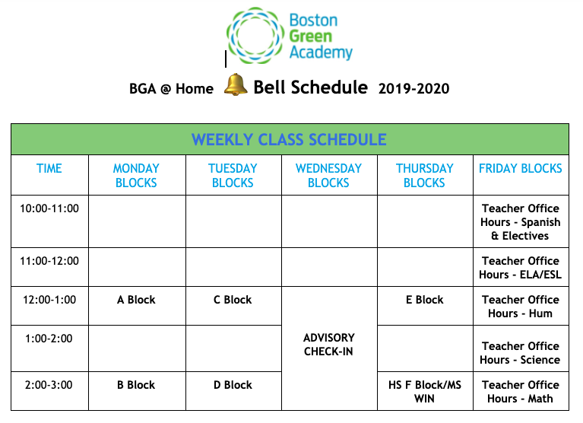

Please note the following:

* **Advisories will NOT meet virtually.** This time is set aside for teachers to make calls/connect with all Advisory members. We expect this time will be spread out across the week as it is still our expectation that each student is contacted by an Advisor every two days. You can also use time on Wednesday for this purpose.
* **Middle School WIN Blocks will meet virtually on Thursdays.** Now more than ever our students need support to strengthen their skills and WIN is a powerful tool to help with this. Including WIN in the master schedule also creates equity between middle and high school teachers in terms of how much virtual teaching time is required for everyone (4 out of 6 blocks, 4 hours per week). We understand there will be many questions about how this works. Alicia Eberle, our Interventions Coordinator, will share more guidance and tools this week. We have two weeks to plan for this, which should allow us ample time to be ready. Thanks for embracing this as an opportunity to help our kids. We will figure out the logistics together.

For a list of courses that will meet virtually and those that will not, please consult this [weekly schedule list](https://docs.google.com/spreadsheets/d/1hPH1KBouhO7fE6FkDKCoxrOpazkabyp2scv9O3ogbl0/edit?usp=sharing). A snapshot is also below:

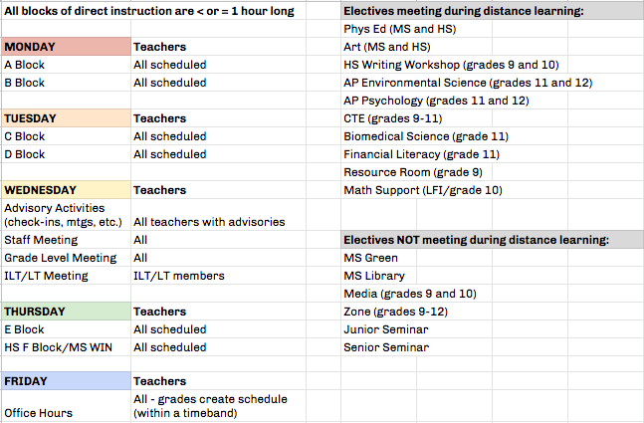

The full [Master Schedule can be found here](https://docs.google.com/document/d/1nncVlGIk8kdk4f1vKpC2J2VgP248U_bf3Or8KOQq8H8/edit?usp=sharing) and is excerpted below. This includes grade level meetings and the weekly staff meeting. As of this writing, SST meetings have not yet been added and will need to be adjusted to accommodate the new master schedule. Office hours must be held during these master schedule times. There will be minor adjustments to this schedule going forward and we will update this document.

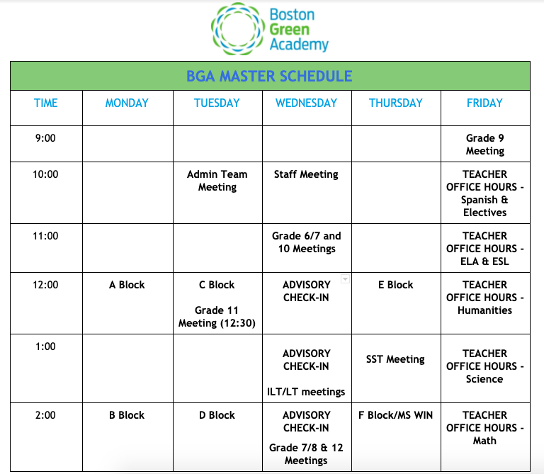

**Version: April 26, 2020**

**Resources from BPS: ESL & Special Education**

We know that providing ESL and Special Education services under these conditions is difficult but essential. There are still many questions to work through but we’ll do our best. For ELL/ESL questions, please connect with the ESL Team and/or Jeff. For Special Education, please connect with June, Jennifer or Cheryl Graham. BPS has published updated guidance about ESL & Special Education supports in [this document here](https://drive.google.com/file/d/16718ihOi3ITbGSamHvdhj_Myoz524j2Z/view?usp=sharing). Everyone should read it, especially if you teach a Sub Sep or ESL section. However, we know that what BPS has written may not easily fit into our Virtual Learning Plan. Please connect with Amanda, Jeff, or myself if you have questions. Thanks for supporting our ELLs and Students with Disabilities in this challenging time.

**Paraprofessional Expectations**

BGA Paraprofessionals have the following work expectations going forward, in addition to other work you have been doing::

* Attend weekly synchronous virtual lessons for each assigned class from the regular school year.
* Be available as needed to assist during your partner teacher’s office hours - there is significant overlap of teachers in this area for those paras assisting in the same content more than once. Please partner with teachers to see how best to engage in a limited capacity in these circumstances.
* Attend weekly staff meeting via Zoom.
* Assist students (with a priority focus on the students in your classes) with small group and/or individual tutoring sessions. These will take place outside of the class times that you are scheduled for and should be logged in your weekly work plan that is shared with your supervisor.
* Maintain a log of communication and tutoring sessions including student name(s), date, time, and content/notes.

If you have questions, please connect with Jeff.

**SST Expectations**

BGA SST members have the following expectations going forward, in addition to other work you have been doing:

* Communication with students should be attempted everyday and logged in the SST daily log.
* Maintain weekly communication with students on your target list and/or caseload.
* Respond to referrals for support regarding a lack of engagement within two days. Log said communication in the SST Daily Log.
* Attend Grade Level meetings as needed.
* Attend weekly staff and SST meetings via Zoom.
* Communicate with families as needed and log contacts
* Monitor weekly attendance of students and follow up with engagement strategies.
* Provide virtual counseling, when appropriate, individually or in groups.
* Provide guidance services for both middle and high school.
* Attend virtual professional development as required by the BPS.
* Collaborate with partners and outside resources to provide resources for students and families.
* Attend IEP meetings as required.
* Observe/attend virtual classes to gain experience with new expectations for students or if requested by a staff member.

If you have questions, please connect with Jeff or Brian.

**Required PD on Virtual Learning**

As part of the BTU/BPS agreement, all teachers, paraprofessional and counselors will partake in 5 hours of online PD about virtual learning best practices. BPS has selected a vendor for this PD ([LincSpring](https://www.lincspring.com/)). You will be able to do that at your own time/speed, but completion will be tracked by BPS. See other documents shared by Amanda for details.

**Use of Zoom and Google Classroom Accounts**

As previously shared and effective immediately, all virtual classes must use BPS Zoom accounts (they have enhanced security) and all Google Classrooms must have your BPS email address added as a teacher (so BPS can track student usage). The BGA Zoom account will be discontinued (meetings for May 4th and beyond will have to be rescheduled with new login codes). Please see Ryne if you have any questions.

**Roll Out Plan/Next Steps**

We will use this week ahead to plan for the launch of our new phase of virtual learning on Monday, May 4th. Here’s what you can expect:

**Monday, April 27th, Evening:** Email goes out to parents inviting them to a family orientation for virtual learning and giving them instructions.

1. [Instructions for students to add Zoom to their chromebook](https://support.zoom.us/hc/en-us/articles/213298746-Getting-Started-On-Chrome-OS)
2. Ryne Deckard is inviting you to a scheduled Zoom meeting.

Topic: Zoom Info Meeting

Time: Apr 28, 2020 06:30 PM Eastern Time (US and Canada)

Join Zoom Meeting

https://k12-bostonpublicschools.zoom.us/j/88163016364?pwd=NmRuNk9ReFhuTkNyd1NaQzMxUHJvUT09

Meeting ID: 881 6301 6364

Password: 002941

One tap mobile

+13126266799,,88163016364#,,#,002941# US (Chicago)

+16465588656,,88163016364#,,#,002941# US (New York)

Dial by your location

+1 312 626 6799 US (Chicago)

+1 646 558 8656 US (New York)

+1 253 215 8782 US

+1 301 715 8592 US

+1 346 248 7799 US (Houston)

+1 669 900 9128 US (San Jose)

Meeting ID: 881 6301 6364

Password: 002941

Find your local number: https://k12-bostonpublicschools.zoom.us/u/kdeb5nNAFK

1. [Give out Chromebook request form for those that still need it](https://www.bostonpublicschools.org/Page/8131)
2. [Internet information for those that need it](https://www.boston.gov/news/internet-connectivity-and-technology-supports-during-covid-19-response)

[Getting Started for Students](https://www.youtube.com/watch?v=wbnyQwsVbiY)



**Monday, April 27th, Evening:** Email goes out to teachers

1. [Instructions to download zoom](https://support.zoom.us/hc/en-us/articles/201362033-Getting-Started-on-Windows-and-Mac)
2. Login with BPS email and password for security purposes
3. [One pager with Zoom security tips and helpful hints for use with students](https://docs.google.com/presentation/d/1-rJXbgEQbSTHkuWIDqZ1GCgOGbMD46cYNTWMiGTHtwM/edit#slide=id.g735b88f541_169_0)

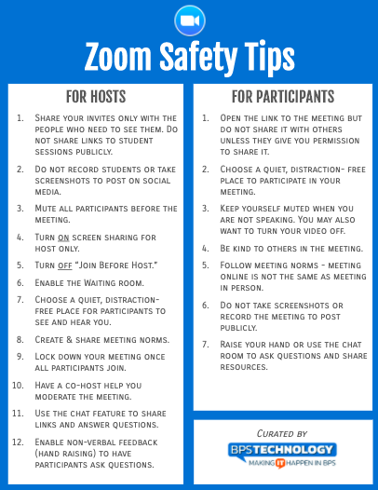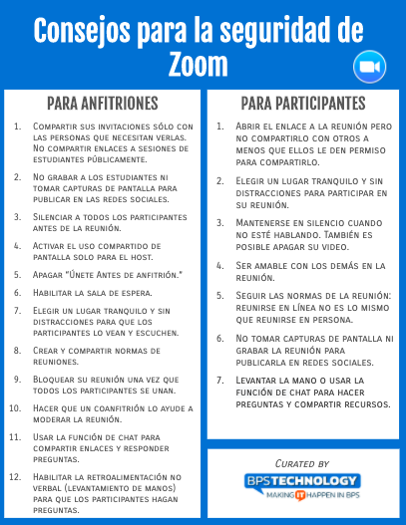

1. Zoom help session (I will primarily answer questions but show off some features such as breakout rooms and scheduling)...either in Grade Level Teams or invite will be went out for those that need.

[Zoom Help For Teachers](https://www.youtube.com/playlist?list=PLKpRxBfeD1kEM_I1lId3N_Xl77fKDzSXe)

**Thursday, April 30th or Friday, May 1st, Initial Large Group Zoom Meeting for Students**

1. Thursday or Friday for all students.
2. Can be by advisory, grade level, or whatever is best for each grade (to be discussed in staff meeting and LT)
3. Opportunity for students to get used to Zoom
   1. We want students and teachers to get a feel for the platform
   2. Can have a large group discussion
   3. Can use breakout rooms to go into small groups and do circle discussions.
   4. Show and tell type activities work great.
   5. Remember some students will hate the idea of being on camera for everybody to see.

Launch Zoom in classes on May 4. Start with a low stakes lesson plan. Main objective should be to get the whole class online together.

**That’s all for now. Thank You!**